Getting a new prescription?

Ask your doctor to send   
your prescription for a 3-month   
supply electronically to Express Scripts Pharmacy. This is   
the fastest way to get your medication. You can also log in   
to [express-scripts.com/rx](https://www.express-scripts.com/rx) or through the Express Scripts® mobile app, select “Request an Rx” and follow the prompts. Or call the number on the back of your prescription ID card.

Already taking a long-term medication?

After you log in to   
[express-scripts.com/rx](https://www.express-scripts.com/rx) or through the Express Scripts mobile app, you may see existing prescriptions that are eligible for home delivery. If you have refills available, simply add them to your cart and place your order. We’ll contact your doctor and take care of the rest.

Are you getting the most from your pharmacy   
benefits? Under <Plan Name>, you can use home delivery through Express Scripts Pharmacy by Evernorth® to fill 3-month supplies of your prescriptions. We wanted to make sure you knew how Express Scripts Pharmacy makes getting your maintenance medications simpler and more convenient.

A different kind of pharmacy

With Express Scripts Pharmacy, you get your medications delivered right   
to your door quickly, safely and accurately. And with automatic refills, you’ll always have your medication on hand without extra trips to the pharmacy.1

You could even save 32% on your prescriptions as compared to retail pharmacies.2 Other benefits include:

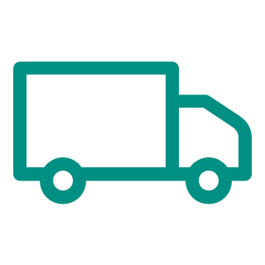Standard shipping at no cost to you3 and flexible payment options

Specially trained pharmacists available 24/7 to answer questions

Easy-to-use app to track orders, refill prescriptions and more

Get your medications from Express Scripts Pharmacy and see what it means to have a pharmacy built around you and your health.